INVESTMENT SERVICES
Belmont Savings Bank (BSB) has partnered with Commonwealth Financial Services to offer enhanced financial options to BSB customers.
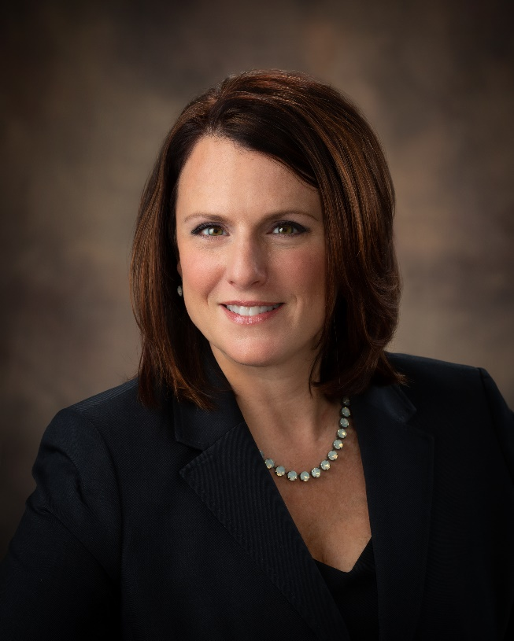
- Financial Planning
- Oil and Gas Planning
- Risk Management
- Retirement Preparation
- Saving for College
- Investment Advice
- Stocks and Bonds
- Mutual Funds
- Fixed and Variable Annuities
- Retirement Plans
- Tax-Advantaged Investments
- Professionally Managed Assets
- Life Insurance
- Long-Term Care Insurance

Julie Vavra Daley, Financial Advisor
julie.daley@cfswv.com I 740-296-5066

With over 15 years of experience in the investment and insurance industries, Julie serves as a financial advisor at Commonwealth Financial Services (CFS). Prior to joining CFS, she managed her own independent financial planning practice in St. Clairsville, Ohio. In 2017, she was recognized as a Retirement Income Certified Professional® (RICP®) by The American College of Financial Services®.
She holds Series 6, 7, 63 and 66 licenses, as well as life, health and disability insurance. She attended Capital University, where she earned a bachelor’s degree in business management and finance in 2001. Since returning to the Ohio Valley, she has been actively involved in many organizations, including the Ohio Valley Business and Professional Women’s Club, where she served as the local president and vice president of the region. She is a current board member of the Ohio Valley Oil and Gas Association, as well as chairperson of the Industrial and Technical Education Coalition. She also sits on the Board of Directors for Belco Works/Tomorrow’s Corner.
To learn more about Julie and Commonwealth, visit their website www.cfswv.com or call 740-296-5066.
Check the background of this investment professional on FINRA's BrokerCheck.
Securities offered through Securities America, Inc. Member FINRA/SIPC, Advisory Services offered through Arbor Point Advisors. Commonwealth Financial Services, Securities America and Arbor Point are separate entities. Not FDIC Insured • No Bank Guarantees • May Lose Value • Not a Deposit • Not Insured by any Government Agency

